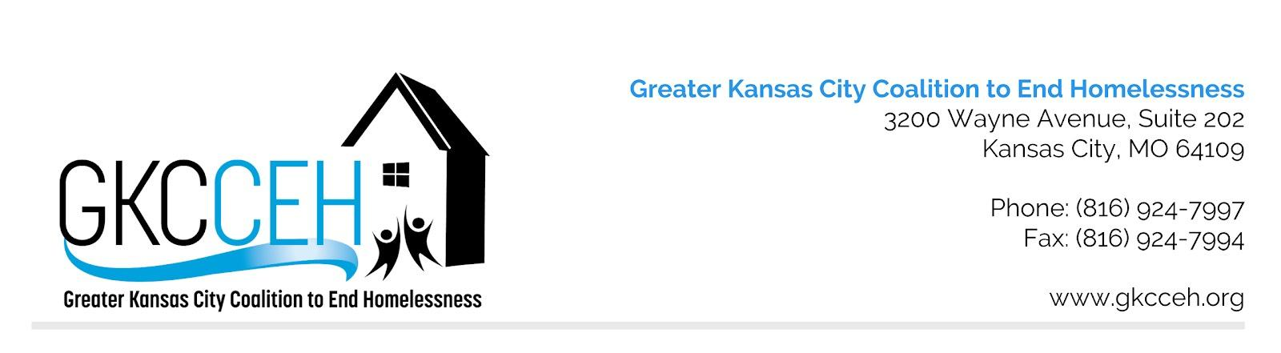

MO-604 Kansas City (MO&KS), Independence, Lee’s Summit/Jackson, Wyandotte Counties
Appeals Policy and Procedures for HUD CoC Award Competition

Original Approval | 8/2/2018
Approved Revisions

Policy: The CoC notifies project applicants administering a project that has been reduced, rejected, or reallocated in writing and by phone at least 15 days prior to the HUD application deadline, in accordance with HUD’s NOFA policies and procedures. The notification will include the reasons for the reduction, rejection, or reallocation. Agencies whose renewal project(s) have been rejected and meet one of the policy criteria for appeal may appeal the decision within three (3) days of the notification of project rejection via the process described herein​. This policy is reviewed annual for adherence to the current year’s NOFA.

Items that CAN be appealed:
- Violation of federal guidelines on the part of GKCCEH or Rank and Review
- Violation of CoC written policies on the part of GKCCEH or Rank and Review
- Data that has not been monitored by GKCCEH or submitted to HUD via the Annual Performance Report (APR)
- Participation points (to prove attendance as required by the Participation Requirements for Eligible Applicants policy)

Items that CANNOT be appealed:
- Errors or omissions on the part of the applicant
- Threshold not met by applicant
- Not attending mandatory trainings outlined in the posted timeline
- Missing/late attachments or submission
- Position within Tier structure
- Data that has been monitored by GKCCEH or submitted to HUD via the Annual Performance Report (APR)

Procedures:
- Appeal must be submitted within three (3) days of rejection or reallocation by email to the designated CoC staff person detailed in the NoFA timeline, published on the NoFA link of www.gkcceh.org. Agencies with valid appeals must do so in writing, on agency letterhead, in no more than 2 pages in length.
- Within three (3) business days of receipt of the appeal:
- A subset of the GKCCEH Board of Directors, called the Board Appeals subcommittee, comprised of a minimum of 3 board members, none of whom shall be service provider staff, will discuss any appeal submitted through the above-mentioned process to review eligibility of the appeal. Eligible appeals will progress on to the Rank and Review Committee for consideration.
- Rank and Review, in conjunction with the Board Appeals subcommittee, will review the appeal and any supporting documentation provided by the agency and will make a determination as to whether a score and/or ranking decision should be altered based on the appeal.
- The Board Appeals subcommittee will make final determination and transmit to the Board of Directors for their concurrence.
- The Board’s final decision will be posted on the website for all CoC members and an email message will be sent to the applicant making the appeal.
- Further appeal is not eligible after the final decision of the Board of Directors, outside of a direct appeal to HUD, as referenced below.
- Agencies whose rank may be affected, i.e., those whose recommended ranking is Tier 2, may be notified as a courtesy. Such agencies will not be able to file a local appeal after the 3 day time period to appeal has passed.
- Project applicants whose project was rejected may appeal the local CoC competition decision to HUD if the project applicant believes it was denied the opportunity to participate in the local CoC planning process in a reasonable manner. They may do so by submitting a Solo Application in e-snaps directly to HUD prior to the application deadline. Refer to the current HUD Continuum of Care NOFA for this process.

The Appeals Process with HUD is found at 24 CFR 578.35. Sections 578.35(b)(3), (b)(4), (c)(1), and (d)(2) which authorize HUD to establish requirements for the form and manner for appeals by applicants.

