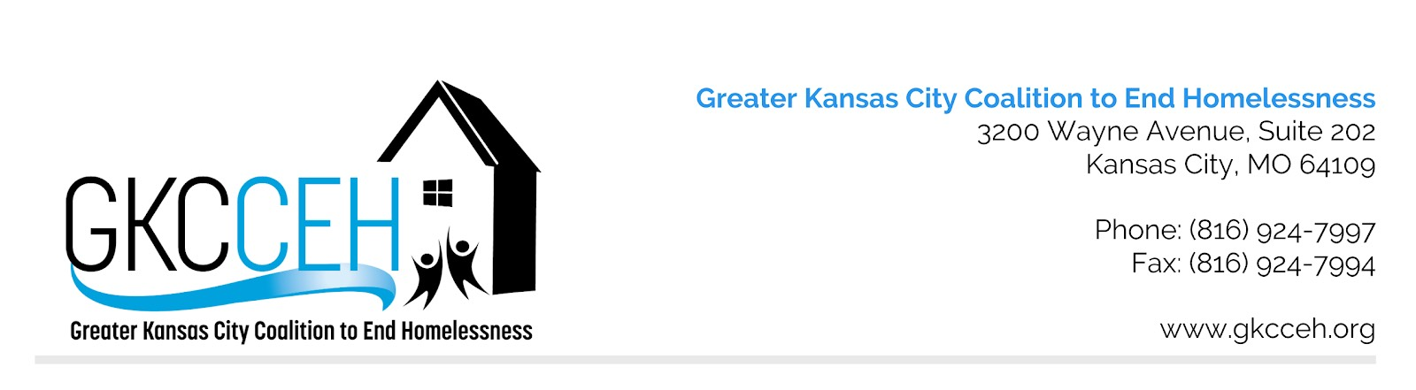
MO-604 Kansas City (MO&KS), Independence, Lee’s Summit/Jackson, Wyandotte Counties
Prioritization Policy and Procedures for HUD CoC Award Competition

Original Approval
Approved Revisions

1. To be eligible for prioritizing and ranking, all projects – new and renewal – must pass all facets of the application evaluation process including:
a. All projects must meet all HUD eligibility criteria
b. All projects must be HEARTH & CoC regulation compliant
c. All projects must meet the application deadlines as set by the GKCCEH-CoC and HUD
d. All projects must meet eligibility criteria outlined in HUD NOFA
2. Ranking within Tiers will be based on scores from the CoC Rank and Review committee, using the scoring tool, project performance, and local need as demonstrated by data. The Rank and Review Committee will also consider which projects will be most competitive in the CoC funding process based on HUD’s HEARTH Act performance measures and HUD’s policy priorities as outlined in the HUD CoC NOFA. Specific project prioritization will be determined annually and disseminated to the CoC membership and the Rank and Review Committee.
3. The renewal project scoring tool emphasizes projects that promote the HEARTH Act goals of ending homelessness and HUD’s policy priorities as outlined in the NOFA. Measures that reflect HUD’s expectations regarding project performance review are considered. Annual Performance Reports are used to measure project outcomes and performance.
4. The CoC Administration committee will review HUD’s policy priorities as outlined in the annual NOFA and determine if any changes need to be made to the local scoring or ranking process in order to best align with HUD’s priorities and requirements. The committee reserves the right to make any changes as needed to ensure compliance and competitiveness. All changes made will be reviewed and approved by the GKCCEH Board.
5. All new project applications for CoC bonus dollars will be evaluated by the CoC Rank and Review committee. The Rank and Review committee will determine whether or not new project applications for bonus dollars will be included in GKCCEH/CoC application to HUD.
6. New project applications for CoC bonus dollars will be most competitive if they align with HUD policy priorities, demonstrate the organization capacity to administer federal grant funds, demonstrate a clear understanding of best practices in the delivery of the program model, adopt a Housing First model of service delivery, and meet local need.
7. Projects required by HEARTH & the CoC Regulation will be ranked in Tier 1 because the projects are federally required, and the primary funding source for these projects is HUD CoC funding, i.e., HMIS (Homeless Management Information Systems Requirements) and Lead Agency.
8. The CoC Lead agency will not participate in any discussion or deliberation about prioritization that may impact their funding.

