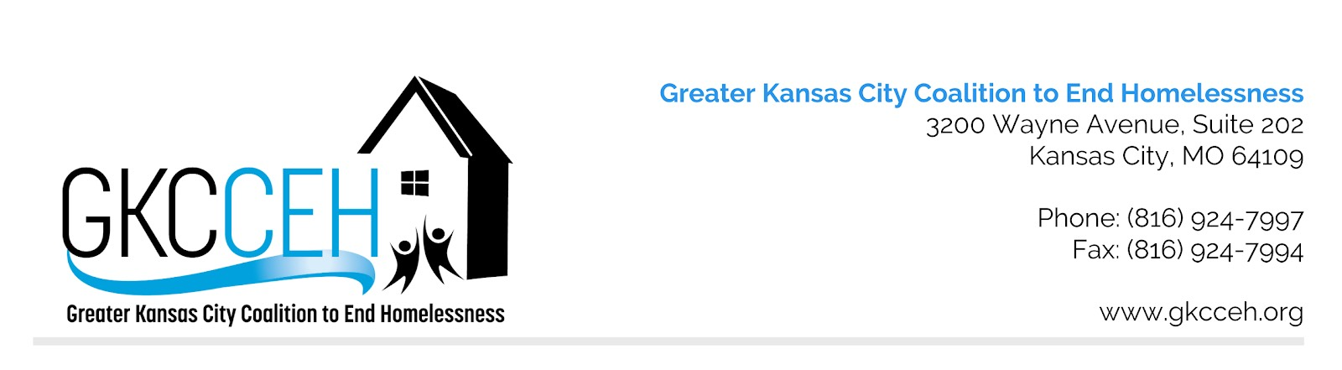

MO-604 Kansas City (MO&KS), Independence, Lee’s Summit/Jackson, Wyandotte Counties
Application Ranking Policy and Procedure for HUD CoC Award Competition

Original Approval
Approved Revisions

Policy: MO-604 Continuum of Care (CoC) anticipates multiple applications for funding will be submitted each HUD CoC NOFA cycle and thus utilizes a Rank and Review Committee to evaluate project applications and rank them in priority order, utilizing both HUD and locally defined priorities. The CoC aims to improve the homeless system’s performance and therefore welcomes new projects and renewal projects that fill identified data-driven gaps and needs. The CoC establishes specific, consistent guidance on the ranking of several types of applications:
- A Lead Agency HMIS (Homeless Management Information System) project application and a Lead Agency CES (Coordinated Entry System) project application each will be placed in Tier 1 as community priorities, demonstrating the Continuum of Care’s continued commitment for a coordinated entry system that collects useful, usable data;
- Lead Agency requests for HMIS and/or CES expansion will be considered at the recommendation of the Finance and Administration Committee in accordance with current local data.
- 1st year renewals will be placed in Tier 1 in accordance with HUD guidance. 1st year renewal projects will be ranked against each other utilizing their ranking from the year they were approved for new project funding.
- 2nd year renewals with no APRs yet submitted will be placed in Tier 1 because they cannot be ranked based on performance and should not be negatively affected. 2nd year renewal projects will be ranked against each other utilizing their ranking from the year they were approved for project funding. 2nd year renewals shall be ranked above 1st year renewals
- Any renewal project that has not submitted an APR due to receiving an extension shall submit verification of HUD approved extension.

Procedures:
- The GKCCEH Board of Directors, staff, and Administration Committee recommend individuals to serve on the Rank and Review Committee, comprised of between 6-16 community members that are not connected with any organizations competing in the NOFA program competition.
- GKCCEH staff conducts a technical review of all HUD CoC Program applications submitted.
- Staff submit to the Rank and Review Committee all renewal and new projects which meet the technical threshold standards.
- GKCCEH staff inform Rank and Review Committee of the ranking policy standards; educate on local population data and system strengths and weaknesses; and provide technical assistance to the Committee regarding questions that arise.
- Additionally, the GKCCEH Board of Directors, staff, and committees (e.g., Administration and Finance Committee, Progress and Evaluation Committee) may give the Rank and Review Committee instruction regarding community priority projects – these projects should be limited and should provide benefit to all persons served within the CoC.
- The Rank and Review Committee reads, reviews, and uses HUD and locally defined priorities and a point-based evaluation form to score, rank, and/or reallocate NOFA grant applications. The Rank and Review Committee carefully considers new projects’ potential for improving system performance.
- The Committee comes together and, through consensus, ranks projects – including new projects – in accordance with which will most likely enhance system performance. Once the first priority application is established, the remainder of funds available shall be allocated to the second priority application, etc. until all available funds are included in the GKCCEH application for grant funding. HUD uses a tier system, with Tier 1 projects more likely to be funded than Tier 2 projects. The Rank & Review Committee may place a project on the Tier 1 and Tier 2 break, with the understanding of the risk to the portion placed in Tier 2.
- The Committee presents the priority ranked slate of applications recommended for funding to the Board of Directors for final approval.
- GKCCEH staff notify all agencies of the Rank and Review outcomes.

