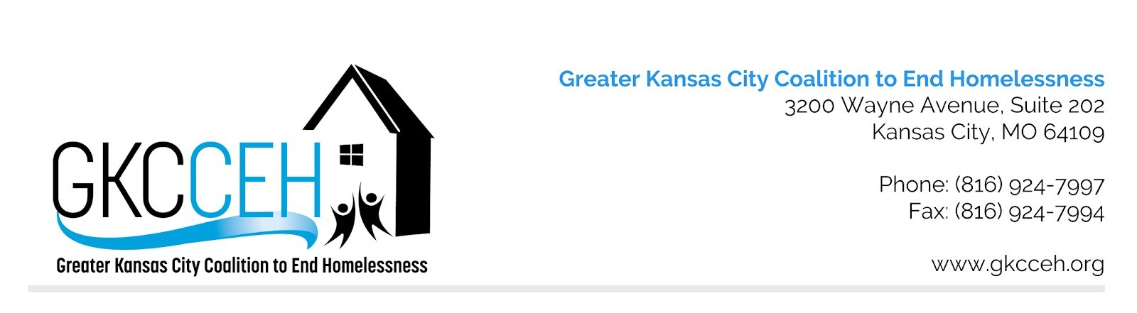

Greater Kansas City Coalition to End Homelessness Jackson/Wyandotte County Continuum of Care (CoC)

Reallocation Policy and Procedures for HUD CoC Award Competition

Original Approval | 8/2/2018
Approved Revisions

Policy: Reallocation refers to shifting Continuum of Care (CoC) funds in whole or part from existing eligible renewal projects to create one or more new projects without decreasing the CoC’s Annual Renewal Demand (ARD). New Projects created through reallocation must meet, at a minimum, the requirements set forth in the annual CoC Notice of Funding Availability (NOFA) and project eligibility and project quality thresholds established by HUD.

The U.S. Department of Housing and Urban Development (HUD) states that one of the primary responsibilities of the Continuum of Care (CoC) is to develop a reallocation process for projects funded with CoC funds. Each year HUD determines eligible reallocation project types in the CoC NOFA. Reallocation may be voluntary or involuntary, in whole or in part.

Decisions to reallocate funds shall be evidence-based. Each CoC funded project will be evaluated annually using specific information to include but not be limited to: data entered into HMIS (or comparable database), HUD Annual Performance Report (APR), Point in Time (PIT) Count, Annual Housing Assessment Report (AHAR), Housing Inventory Count (HIC), the CoC project application, cost reasonableness, HUD CoC system performance measurements, other HUD recommended data tools, and local needs assessments. Reallocation action will be taken with the goal of alignment with HUD and HEARTH ACT policy guidance, alignment with the Federal strategic plan to prevent and end homelessness, performance criteria specified in the annual HUD NOFA, and local data and priorities.

Voluntary reallocation is an act of permanently surrendering HUD grant funds for part of, or a whole project; these funds are then available for new project applicants or expansion projects to apply for. As noted by HUD, voluntary reallocation does not guarantee the agency will be chosen to operate a new eligible project utilizing the reallocated funds.

Involuntary reallocation occurs when the CoC’s Rank and Review Committee determines projects are underperforming, not meeting system performance measure standards, obsolete, or do not contribute substantially to meeting the goals of the CoC for preventing and/or reducing homelessness. GKCCEH considers involuntary reallocation as appropriate and as necessary per the language in the annual NOFA and/or the results of the annual project monitoring site visit.

GUIDING PRINCIPLES
Reallocating funds is an important tool used by CoCs to make strategic improvements to their homelessness system. Through reallocation, the CoC can create new, evidence-informed projects by eliminating projects that are underperforming or are more appropriately funded from other sources. Reallocation is particularly important when new resources are not available. Additional guiding principles include:
- All funds are for the betterment of the community, not solely the individual agency.
- Through a coordinated system, agencies are able to use their funds in a more effective and efficient way to better support the community’s homeless households in reaching permanent housing.
- Failing programs shall be recommended for reallocation.

General Reallocation Procedures:
- Each year, GKCCEH staff, generally in coordination with the Administration Committee, carefully review the HUD NoFA when released, and use the prioritizations noted within the NoFA to guide prioritization and scoring practices for the CoC. Note: Local community priorities, established using local data, gaps analysis, and/or needs assessments, will be given priority consideration and may take precedence over HUD’s priorities.
- The process used in determining reallocation of funds is structured in such a way that increases system performance and mitigates perceptions of reallocation as a threat to an agency or program, i.e., quality programs could be reallocated if they do not fulfill a current community priority need.
- A Rank and Review Committee is established and trained as set forth in the Ranking Policy and associated procedures.
- New Projects created through reallocation must meet, at a minimum, the requirements set forth in the annual CoC NOFA and project eligibility and project quality thresholds established by HUD.

Voluntary Reallocation Procedures:
- Voluntary reallocation happens when, using local data, an agency determines their project:
  - is not meeting local needs,
  - does not have the capacity to continue the project, and/or
  - the reduction of the project would better serve the CoC.
- Currently funded CoC project applicants interested in voluntarily reallocating (in whole or part) shall notify GKCCEH in writing of their intent to reallocate during the Letter of Intent process.

Involuntary Reallocation Procedures:
- Project applicants who do not meet the standards set forth by HUD and the CoC that were documented during the project monitoring are notified in writing and then required to submit a plan of corrective action and increase project outcomes and/or address concerns prior to the release of the following year’s NOFA.
- Projects that do not meet competition threshold or successfully implement their corrective action plan will be subject to involuntary reallocation.
- The lowest 20% of ranked renewal projects will be evaluated by Rank & Review for possible reallocation, in whole or in part. Rank & Review will compare performance outcomes data from the project’s application and scoresheets as well as annual project monitoring. Criteria used to determine recommendations for reallocation include the following:
  - Ability to serve the entire CoC geography;
  - Permanent Supportive Housing dedication;;
  - Bed utilization rate;
  - Non-compliance with HUD or local policies and procedures;
  - Outstanding obligation to HUD that is in arrears or for which a payment schedule has not been agreed upon;
  - Audit finding(s) for which a response is overdue or unsatisfactory;
  - History of inadequate financial management accounting practices;
  - Evidence of untimely expenditures on prior award;
  - History of other major capacity issues that have significantly impacted the operation of the project and its performance;
  - Timeliness in reimbursing sub recipients for eligible costs. HUD will consider a project applicant as meeting this standard if it has drawn down grant funds at least once per month;
  - History of serving ineligible persons, expending funds on ineligible costs, or failing to expend funds within statutorily established timeframes;
  - Projects not meeting locally determined performance thresholds, including CoC system performance measures. Performance and/or data quality outcomes will be collected via HMIS (or comparable database) data and APRs generated for each project; and/or
  - Other factors determined in the competition’s priorities.
- Consideration is given to the potential impact that involuntary reallocation may have on increasing homelessness resulting from a reduction in services caused by the reallocation.
- If the projects do not meet the local threshold for performance of these metrics, the lowest performing project may be recommended for reallocation in whole or in part. If a project is the only one that serves a specific sub-population, partial reallocation may still be recommended, and the other lowest ranking projects should also be evaluated for reallocation.
- APPLICANT NOTIFICATION: Project applicants administering a project that has been recommended for reallocation will receive notification in writing, outside of e-snaps and will include the reasons for the reallocation no later than 15 days before the application deadline, in accordance with HUD’s NOFA policies and procedures.
- Reallocated applicants may appeal according to the separate APPEALS policy and procedures.

